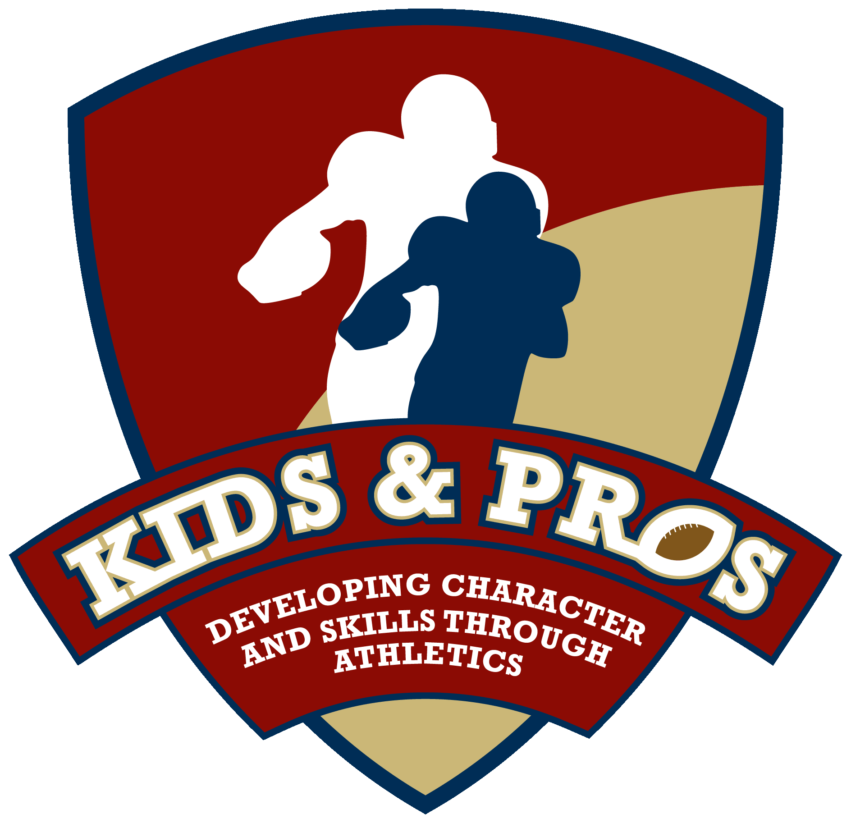

Former Atlanta Falcon, Buddy Curry, To Host Football Camp
at Chastain Park Next Week through Kids & Pros
Camp Will Focus on Teaching Proper Tackling Techniques to Avoid Injuries (like concussions)

Atlanta – For Release July 26, 2013 – Former Atlanta Falcon, Buddy Curry, in conjunction with Kids & Pros, Inc, will offer a special football camp July 29 – August 1st from 5:30 – 8:30 PM at Chastain Park in Atlanta, GA . Youth ages 7 – 13 from the Northside Youth Organization and surrounding communities will have the opportunity to attend the four day camp, which will focus on teaching young athletes proper football tackling technique and other skills to avoid injuries, like concussions. The camp will conclude on Thursday, August 1st with a special awards ceremony and an autograph session for participants.

Curry, a USA Football Master Trainer, incorporates safe tackling techniques from USA Football’s “Heads Up Football” program into the camp along with character-based lessons. The safe, non-contact football instruction teaches campers the right way to play and how to avoid injuries. Camp instructors include current and retired NFL players who provide hands-on teaching of skill fundamentals, as well as position-specific training; the list of instructors supporting the camp next week includes the following seven former NFL players: Bobby Butler (Atlanta Falcons Cornerback 1981-1992), Robert Moore (Atlanta Falcons Safety 1986-1989), Keith Henderson (University of Georgia standout/NFL Running Back –49ers and Vikings--from 1989-1992), Artose Pinner (NFL Running Back- Lions, Vikings and Falcons- 2003-2007), Walter Stith (NFL Offensive Tackle- Browns and Bills 2006-2008) and Floyd Hodge (Atlanta Falcons Wide Receiver 1982-1984.) “This Kids & Pros Football Camp will focus on teaching proper techniques to help participants learn the basics to be prepared for their upcoming seasons,” said Kids & Pros Founder, Buddy Curry (Atlanta Falcons Linebacker 1980-1987).

Kids & Pros Football Camp is supported by the following corporations-- Atlanta Falcons Youth Foundation, Finish Line, Sams, The Shriners, Carter USA, CAS Group, United Healthcare, Dole, Aaron’s , and Kroger. Kids & Pros would like to thank these sponsors for their support and participation throughout the 2013 summer camp season.

Kids & Pros, Inc. is a non-profit organization, started in 2002 by former Atlanta Falcons Bobby Butler and Buddy Curry to teach character and skills through athletics. Through its unique football experience and combination of athletics and wellness education, the organization now provides weekly youth football camps and football safety training across the Southeast. For more information on Kids & Pros, Inc. and next week’s camp, log onto our website at www.kidsandpros.com , follow us on twitter @kidsnpros, or connect with us on Facebook at Kids & Pros, Inc.
###

Contact: Terri Grunduski, Grunduski Group – 404-226-7497
Donna Feazell, Grunduski Group – 404-290-1929

