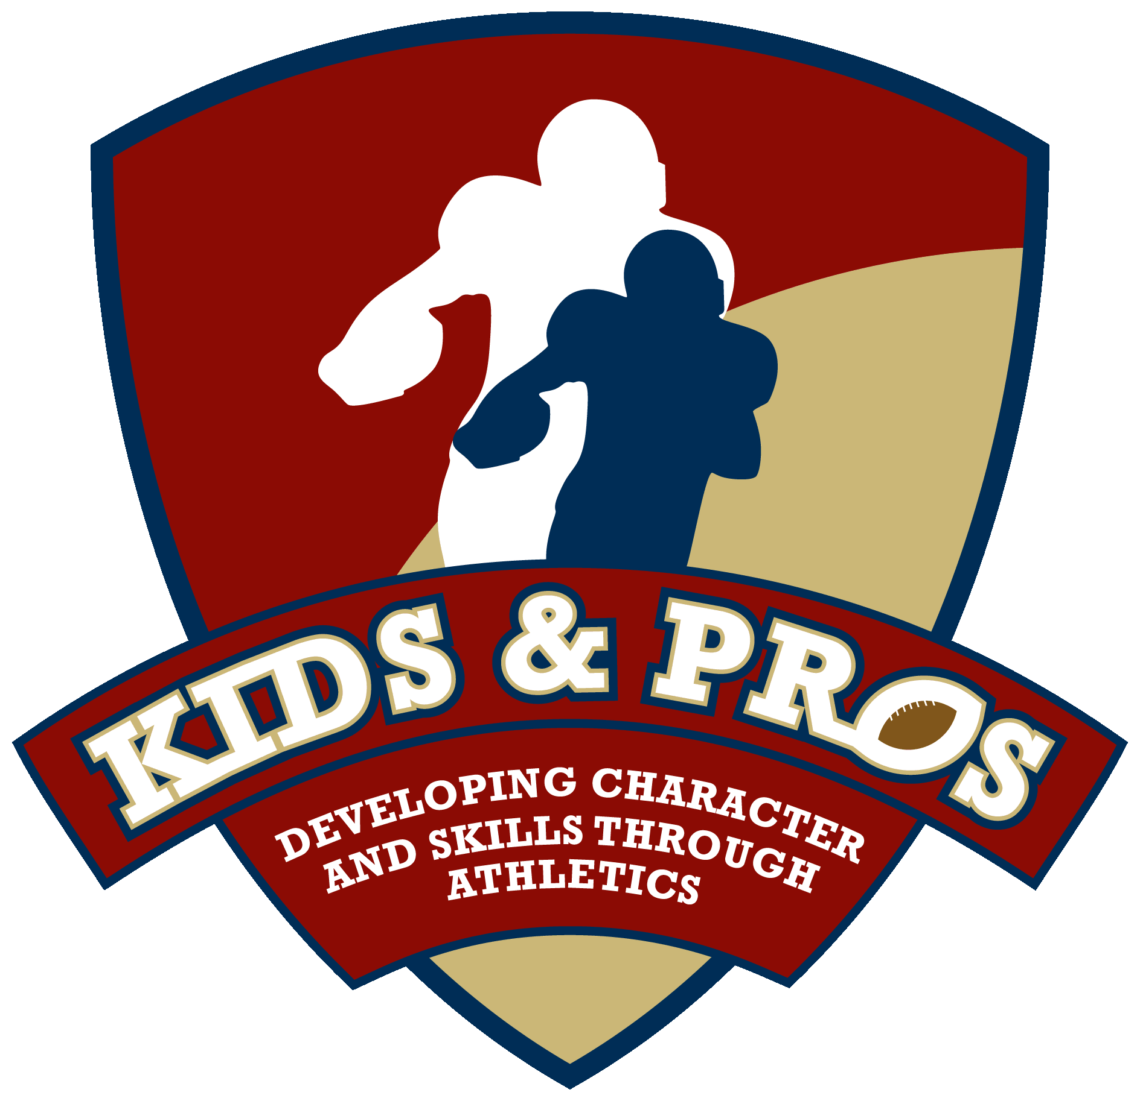

Former Atlanta Falcons Linebacker, Buddy Curry, Heads Up Lineup of Professional Athletes Offering Football & Basketball Camps to Atlanta Inner City Youth This Week
Camps Will Focus on Teaching Proper Tackling Techniques to Avoid Injuries (like concussions)

Atlanta – For Release June 16, 2013 – Former Atlanta Falcon, Buddy Curry, in conjunction with his Kids & Pros Foundation, will offer a free Youth Football and Basketball camp June 17th – 20th from 9AM – 3PM at Henry W. Grady High School located at 929 Charles Allen Drive, Atlanta, GA . Youth age 7 – 13 from Atlanta area Boys and Girls Clubs, YMCAs and other youth organizations will have the opportunity to attend the week-long camps, which will focus on teaching young athletes proper skills to avoid injuries, like concussions. The camps will conclude on Thursday, June 20th with a superbowl game between the campers, an awards ceremony, and a festival from noon – 1pm to promote healthy and positive lifestyle choices to campers and their parents.

Curry, a USA Football Master Trainer, incorporates safe tackling techniques from USA Football’s “Heads Up Football” program into the camp along with character based lessons. The safe, non-contact football instruction teaches campers the right way to play and how to avoid injuries, like concussions. Camp instructors include current and retired NFL players who provide hands-on teaching of skill fundamentals, as well as position-specific training; the list of instructors supporting the camp next week includes: Bobby Butler (Atlanta Falcons Cornerback 1981-1992), Flipper Anderson (NFL Wide Receiver – various teams 1988-1997), Ken Oxendine (Atlanta Falcons Runningback 1998-1999), Chris Slade (NFL Linebacker 1993-2001) and more. “We are excited to host our fifth Atlanta city football and basketball camp,” said Kids & Pros Founder, Buddy Curry (Atlanta Falcons Linebacker 1980-1987). “We enjoy working with the kids to offer camps with great lifestyle and leadership skills from our professional coaches,” said Curry.

The festival will expose campers and their families to the various organizations in the Atlanta community that promote positive and healthy lifestyle choices. Vendors participating in the festival --Dole, United Healthcare, Southeastern Dairy Association (SUDIA), Institute for America’s Health (IAH), 360° Football Academy, Atlanta ContactPoint, Greening Youth Foundation, Sports Edge/ Clean Control, and Atlanta Ballet -- will provide information on positive and healthy lifestyle choices including nutrition, environment, social issues, health, and more.

Kids & Pros would like to thank the following sponsors for their support and participation at this year’s camps: Atlanta Falcons Youth Foundation, CAS Group, The Shriners, United Healthcare, Aaron’s, Dole, Kroger, Clean Control, Sports Edge, Carter USA, Peachtree Communities, UBS, Gatorade, Starbucks, Smith Charities, Staples, Sodexo, and Zaxby’s.

Kids & Pros, Inc. is a non-profit organization, started in 2002 by former Atlanta Falcons Bobby Butler and Buddy Curry in order to teach character and skills through athletics. Through its unique football experience and combination of athletics and wellness education, the organization now provides weekly youth football camps and football safety training across the Southeast. For more information on Kids & Pros, Inc. and next week’s camp, log onto our website at www.kidsandpros.com , follow us on twitter @kidsnpros, or connect with us on Facebook at Kids & Pros, Inc.
###

Contact: Terri Grunduski, Grunduski Group – 404-226-7497
Donna Feazell, Grunduski Group – 404-290-1929

